**HTML & CSS**

You want to create a web page that ranks the food around TIU. Your aim is to design the web page that is both web and mobile friendly. Here is what your webpage should look like:

Further Details:

The page title should use the font ‘Roboto Slab’ with the fallback font ‘serif’. The font size should be 36px, with the font color being white as you plan on using a dark header image on the title. The title needs to be vertical and center aligned to the header image.

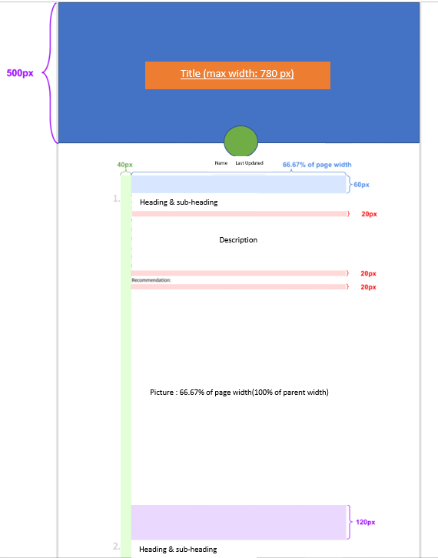

For the profile text, there are two components – the author’s name and when the page is last updated. The font used should be ‘Source Sans Pro’ with the fallback being ‘sans-serif’. The font size should be 18px. The font of the author (you) needs to be in bold. The font for last updated should be in italics. The font color needs to be rgb(51 ,51 ,51) and the line height needs to be 24px.

For the body, the heading needs to be ‘Roboto Slab’ with the fallback being ‘serif’. The font size should be 36px. The font needs to be in bold. The number color (1. 2. 3.) needs to be rgba(0, 0, 0, 0.25) and the title color needs to be rgb(51, 51, 51)

Below the heading, there needs to be an address of the store. The URL for each link (you can use any random URL) needs to be of color #42b4d6. The link is not bold and not underlined, but if you hover over the link, it becomes underlined.

The paragraphs within the page uses the font ‘Source Sans Pro’ with the fallback font ‘sans- serif’. The font size is 18px and the line height is 32px. The font color should be rgb(51, 51, 51).

For the recommendation section after each description, it should take the same style as the description with an additional style of this line being in bold.

For the images, the header uses the background image – .../images/header.jpg. The background does not repeat and the size is set to cover. The background’s position is anchored to the top. The picture’s height should be 500px. There should be a semi- transparent color overlay on top of the header image with a linear-gradient (rgba(0, 0, 0, .3), rgba (0, 0, 0, .3)), url(.../images/header.jpg).

The profile image uses your own facebook profile image (a picture of my face, we can discuss that later) and saved as – .../images/you.png. The width is 100px with rounded corners with radius 100%. It has a white border that is 1px thick.

Design both the HTML and CSS file required to create this page.